**Café Management System**

**Abstract**

The project titled “CAFÉ MANAGEMENT SYSTEM” is design with Visual Studio. Café owner must maintain records of daily billing, which will be used to manage sale report. There will be many items available in the café, many customers will be coming at different time for having food, they will be selecting items from the displayed menu and their bills will be generated. This system will save time and will be easy to use when compared to manual work that was done in paper.

**Objective and Scope:**

The main objective of this project is to manage the details of order. User will take orders from the customer, and only order will be taken at a time. After taking the order system will ask the customer whether to add more item in the order if yes, items will be added, and bill will be displayed

**Module Description**

Login: The customer or manager login to the system by entering valid username and password for making orders.

Manage orders: In this we can see the status of available items, booked items and also the price of the items, number of items and so on.

Customers check in: Here customer fill their details like name, mobile no, address, ID proof and select item type they want.

Customers check out: Here the list of order is shown

**ER DIAGRAM:**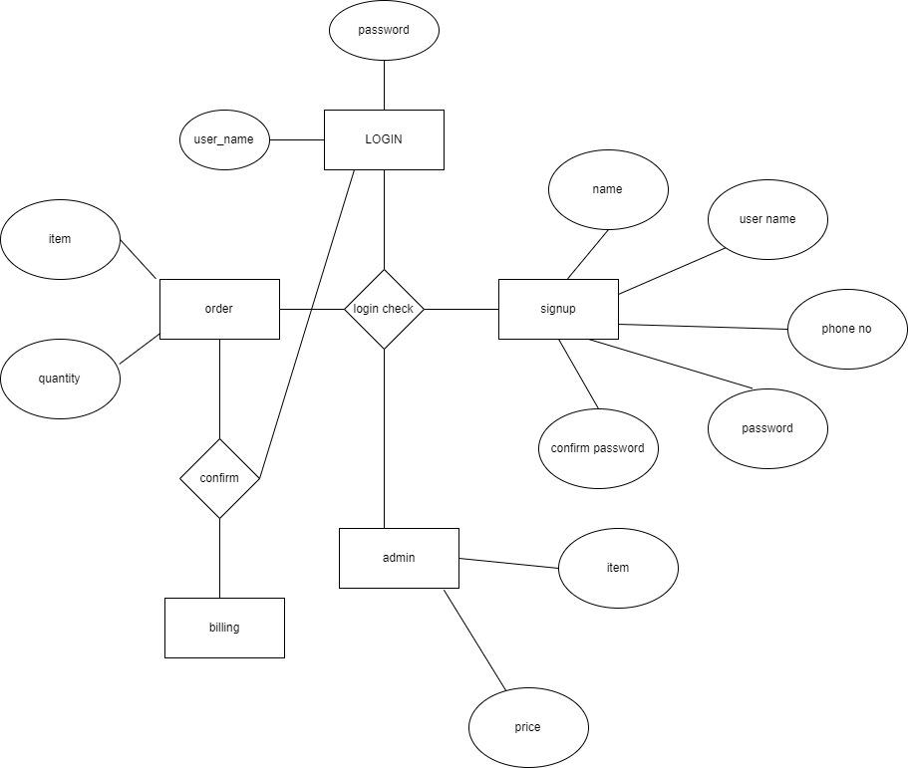

**CLASS DIAGRAM:**

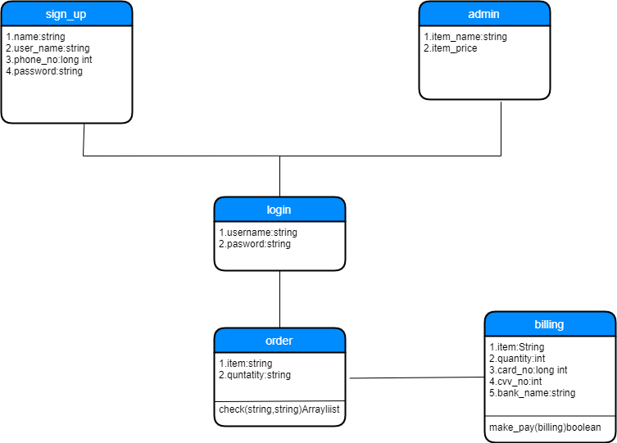

**Use case diagram:**

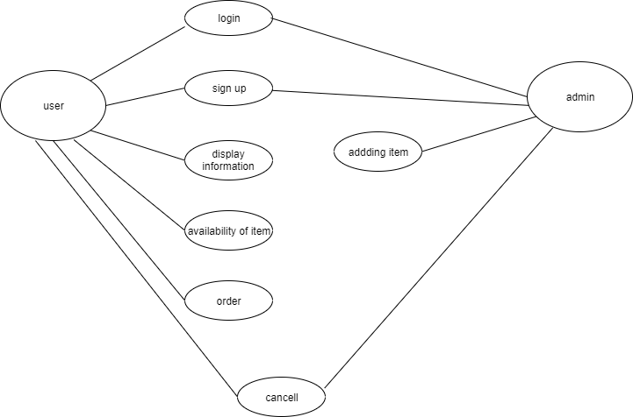

**SEQUENCE DIAGRAM:**

